# DAD 220 Module Two Activity Template

## Overview

Download this template and rename the file to include your last name. Remove these instructions before submitting the completed document for grading. Replace the bracketed text in this template with your answers and any supporting screenshots. Then submit the completed template for grading and feedback.

Using the tables and SQL statements from the Module Two Activity Guidelines and Rubric, answer the questions below. Replace the bracketed text with your answers and any supporting screenshots.

1. How many records are shown in the Employee table?

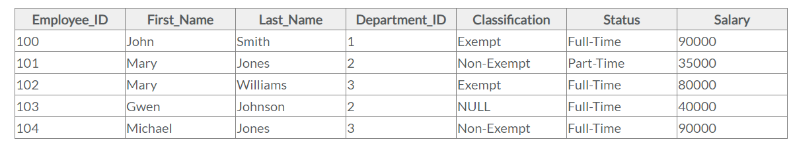

There are 5, ranging from 100 – 104.

1. How many attributes are there in the Branches table?

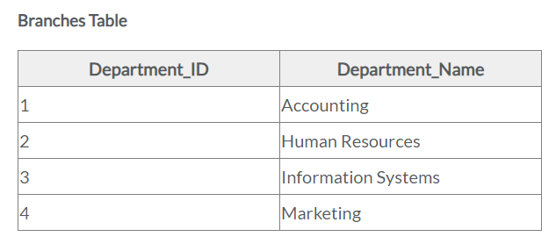

There are 2 attributes according to this Branches Table.

1. Which attribute could be a primary key for the Employee table?

I would assume that the Employee_ID attribute would be key. My reasoning for this is because each employee would have their own unique id number which would make finding their information quick and efficient.

1. What is the maximum number of decimal places that can be stored in an employee’s Salary field?

Maximum decimal places allowed is two.

1. What is the maximum number of decimal places that a Department_ID can have?

There are zero decimal places allowed here, only whole numbers.

1. What three rules do tables obey?
   * + 1. One value per cell.
       2. Columns are not duplicated.
       3. Rows are not duplicated.
2. What is the result of the following query?
   1. Select sum(Salary) from Employee where Department_ID=3;

There are two employees in Department_3 so the sum of both salaries would be 80000 + 90000 = 170000

1. Identify the Employee ID or IDs that would be returned as a result of the following query.
   1. Select * from Employee where Classification != 'Exempt';
      1. Hint: True Null values will not return in the query.

According to the Employee Table there are 2 employees that are exempt and they are 100 and 102. There are 2 more that are non-exempt and one that is NULL which we cannot determine if they are exempt or not from information displayed in the table.

1. What is the result of the following query?
   1. Select max(Salary) from Employee;

The maximum salary displayed for any employee would be 90000.